Experiment 9

**Aim =** To verify Full adder using simulation tool CircuitVerse

**Component Require =** A system , CircuitVerse

**Theory =** In our system ,we use simulation tool that is CircuitVerse to construct basic circuit of Full Adder .

Full Adder carry bit from its previous stage is called carry-in-bit a combinational logic circuit that adds two data bits , A and B and a carry-in-bit , Cin is called a full-adder . The Boolean functions describing the full adder are :-

Sum = A⊕B⊕ Cin

Carry = A.B + B. Cin + A. Cin

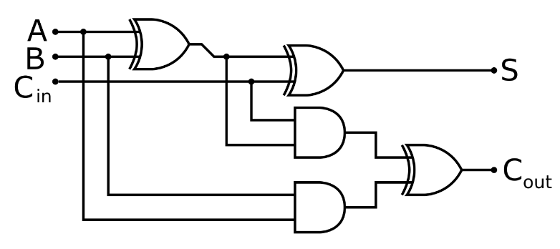

DIAGRAM OF FULL BIT ADDER

**Procedure =**

1. In Simulation , we construct circuit as shown in diagram .
2. We use XOR gates and AND gates for making this circuit .
3. Make sure in simulation all connection should be connected.
4. Verify the Truth Table and observe the output .

**Truth table**

|  |  |  |  |  |
| --- | --- | --- | --- | --- |
| Input | | | Output | |
| A | B | Cin | S | C |
| 0 | 0 | 0 | 0 | 0 |
| 0 | 0 | 1 | 1 | 0 |
| 0 | 1 | 0 | 1 | 0 |
| 0 | 1 | 1 | 0 | 1 |
| 1 | 0 | 0 | 1 | 0 |
| 1 | 0 | 1 | 0 | 1 |
| 1 | 1 | 0 | 0 | 1 |
| 1 | 1 | 1 | 1 | 1 |
|  |  |  |  |  |

**Result =** Hence full adder is verified by simulation .